**Mid-Term Task**

**Part I**

To do this part, I opened the Azure portal, opened up a storage account, and on the storage account blade, under data management, selected static website.

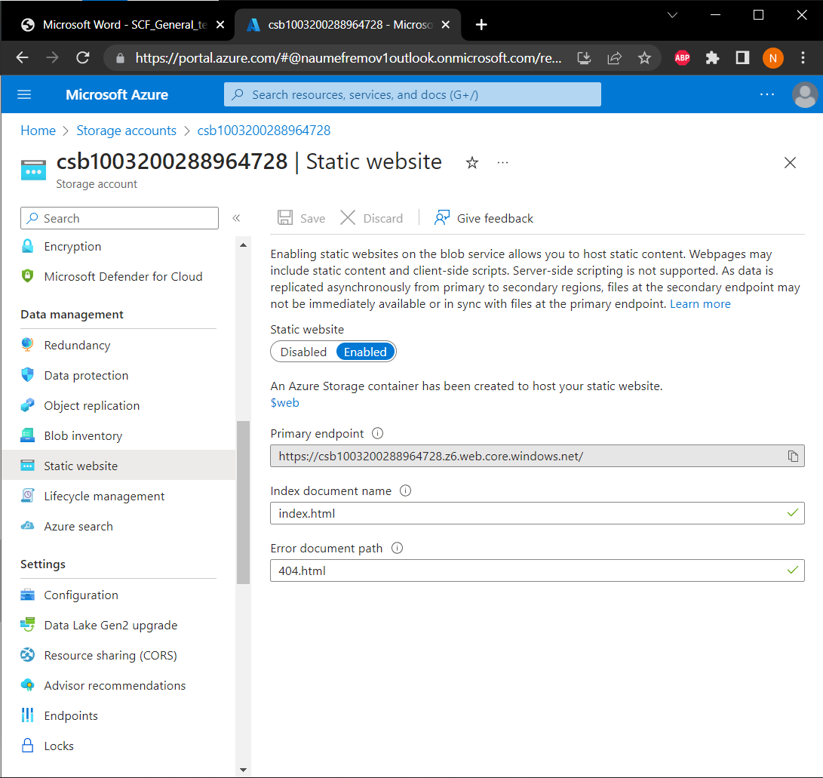I selected enabled under the static website field, and specified the names of the Index document name and the Error document path.

I used Visual Studio Code to create and edit the index file, but before that made sure that I had the Azure Storage, Azure Account and Azure Resources extensions installed.

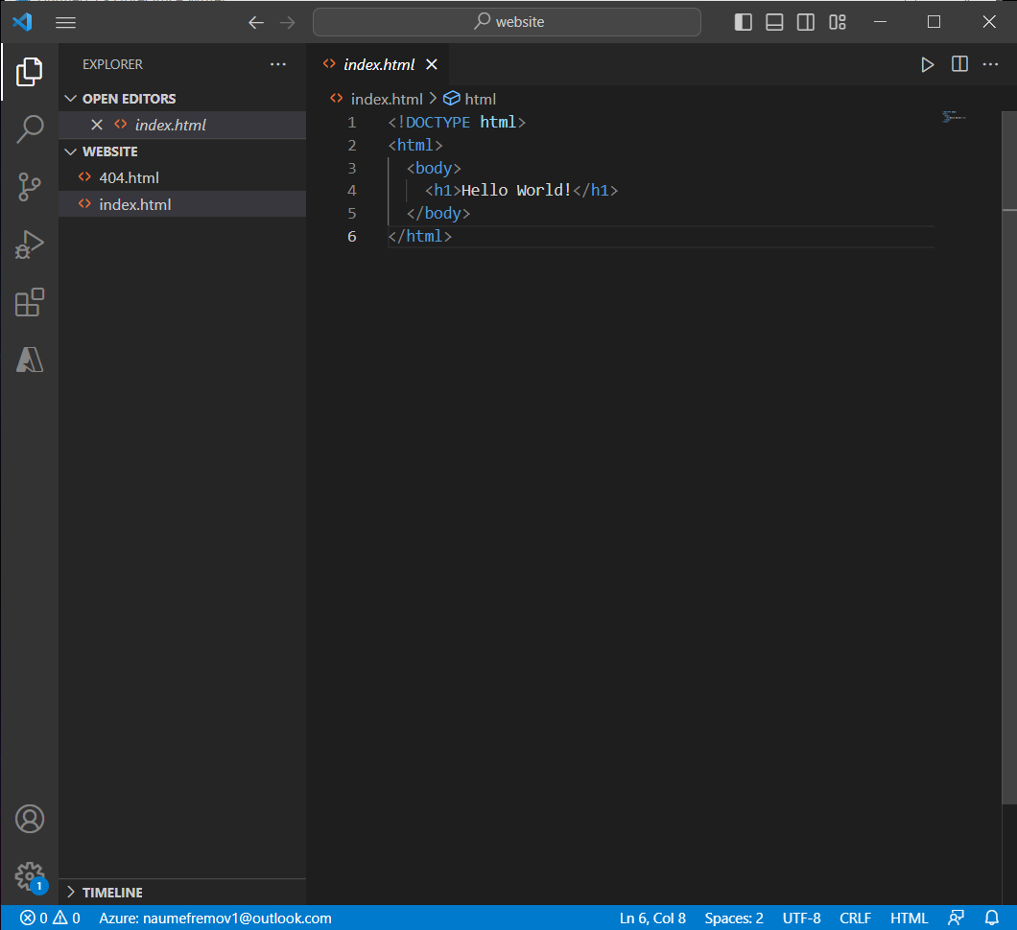

After that was done, I selected Deploy to Static Website using Azure Storage to deploy the website to Azure.

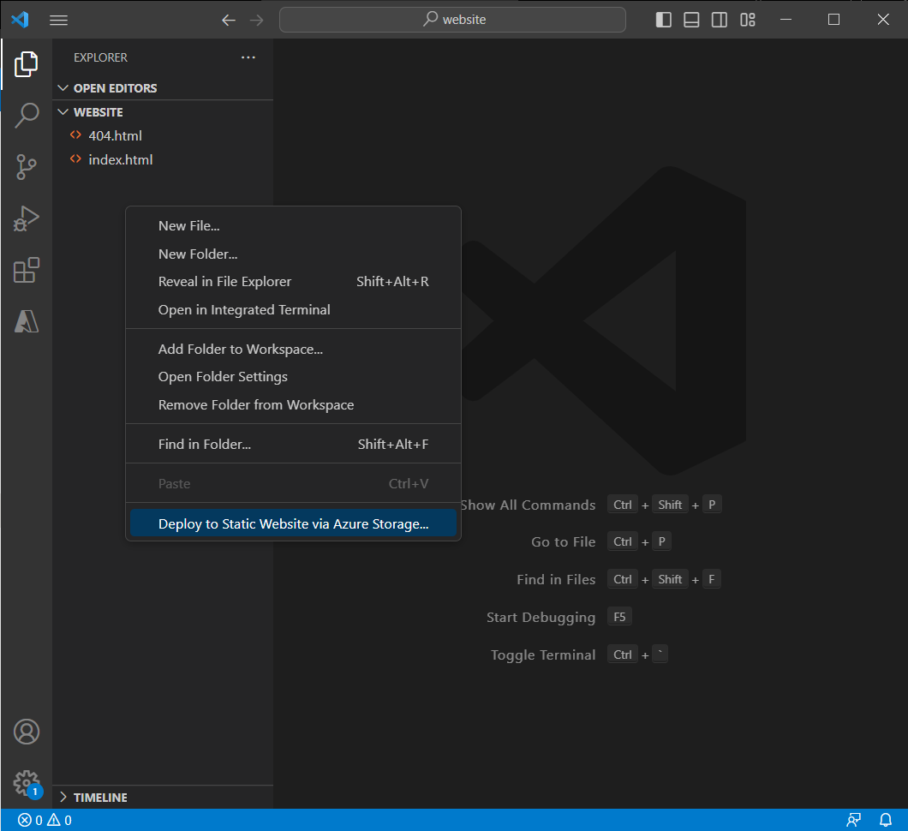

After I went on to sign in to Azure in order for VSC to upload the files, waited for it to finish, came out as successful on the status bar and I managed to open the website afterwards.

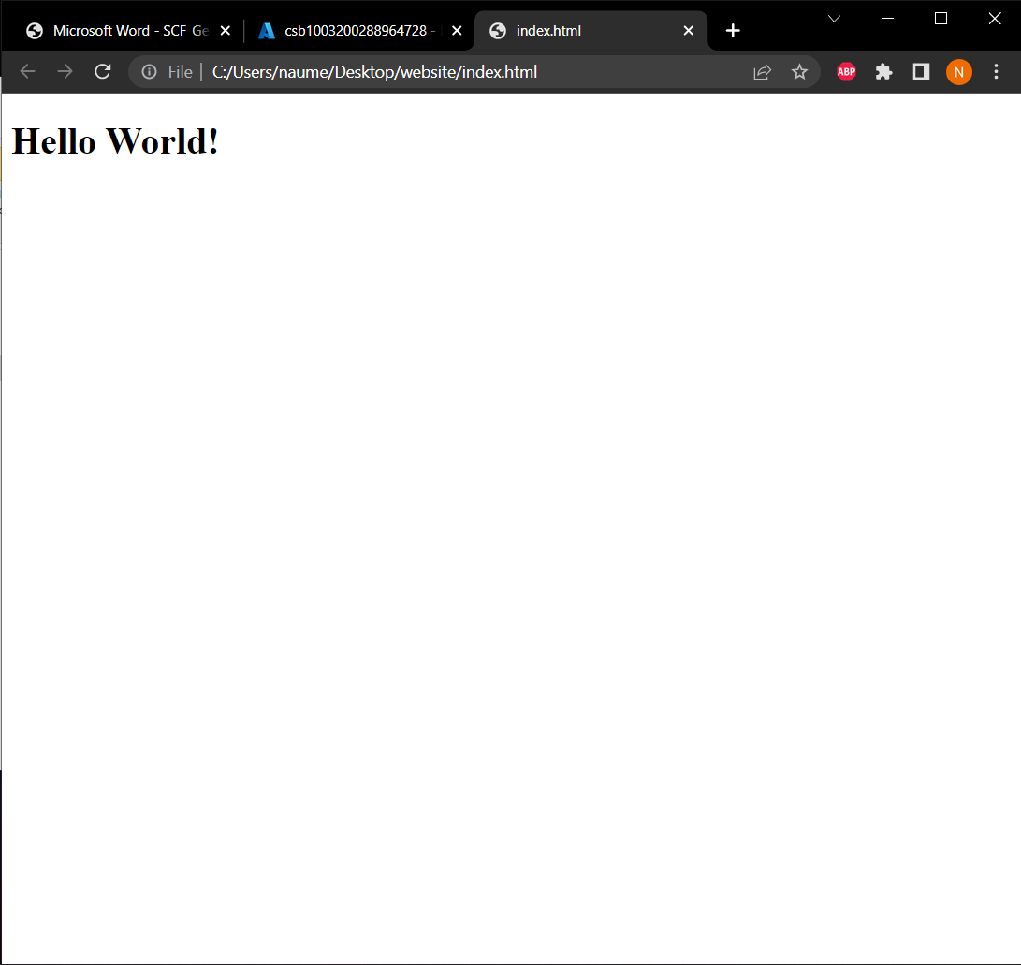

**Part II**

For the second part, I started by creating and modifying the Virtual Network.

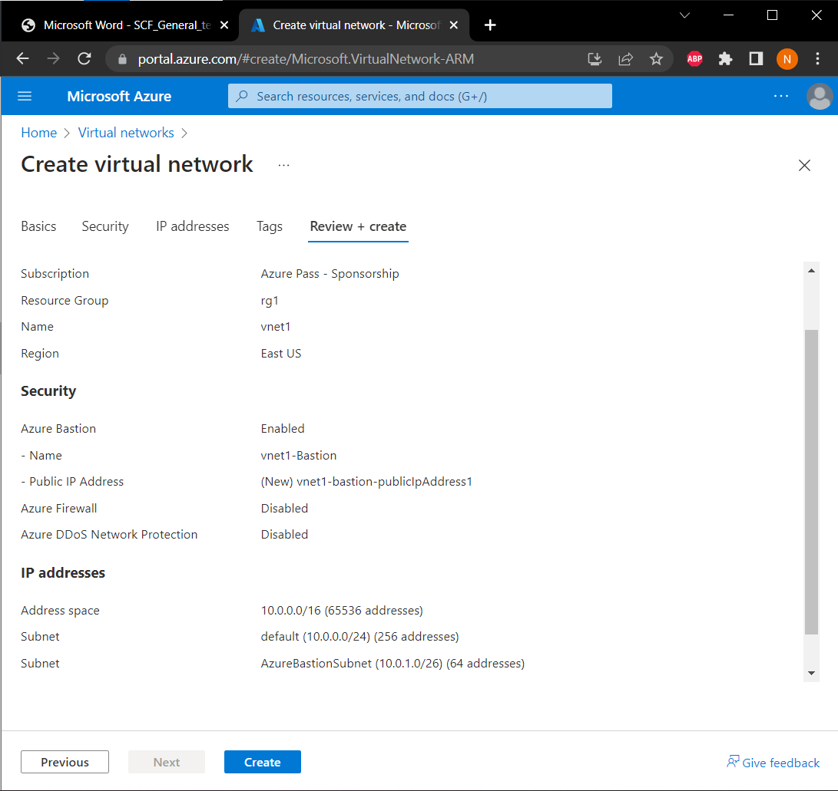

Continued by creating the Linux VM and successfully connected to it.

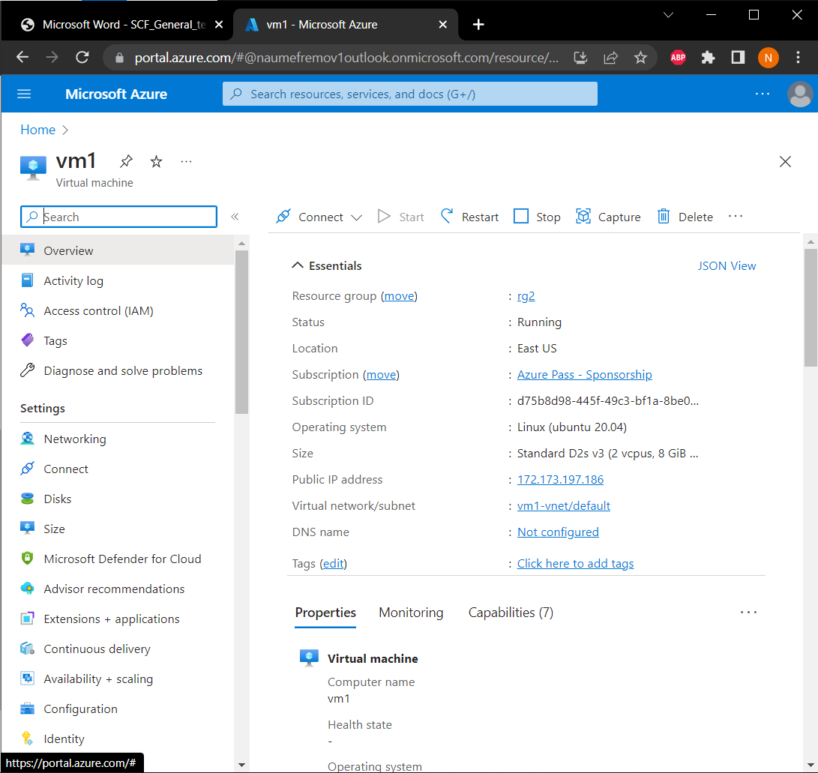

I successfully installed the Apache Web Server as well, but this is as far as I could go since I wasn’t able to deploy the Hello World successfully and it was always giving me an error or blank page and I couldn’t get it to work, I also didn’t have any other ideas unfortunately how I can solve the problem and that is why I can’t provide the needed end results fully.

